AGENDA
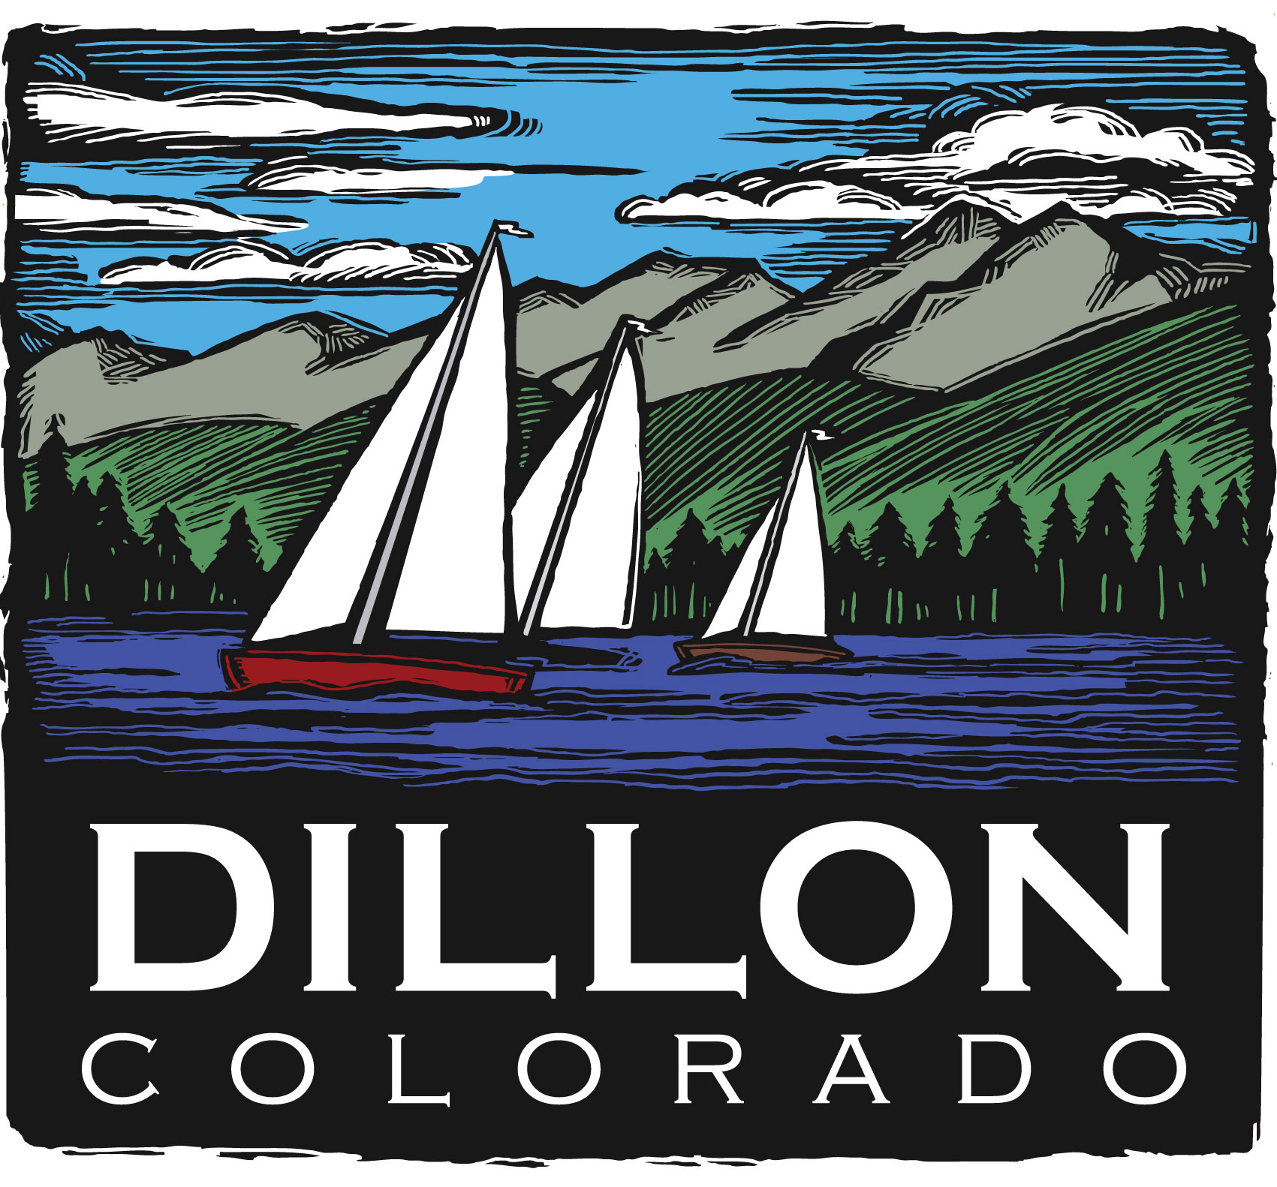
Parks and Recreation Committee
Regular Meeting
October 3, 2011
5:30 PM

Parks and Recreation Mission Statement
The mission of the Parks and Recreation Committee is to protect, improve, and promote our parks and open space for present and future generations. The various park amenities are an integral part of the Town.

Agenda
New Business
- Boy Scout Troop 188/Extreme Sports Concession Stand Report 2011 Season

Old Business
- Wind Issue at Marina Park Pavilion – Continued Discussion – Scott O’Brien
- BOCCE Update – Rick
- Pavers/Trees continued discussion
- 2011 Meeting Dates – remaining
October 3
November 7
December 5
- PRAC Reports to Council – Quarterly.
The PRAC will attend work session/council meetings on the following dates;
November 1
- PRAC Member Terms/Expiration Dates:
Bonnie Hamilton 1/2013
Sue Peterson 1/2013
Rick Giamanco 1/2012
Susan Juergensmeier 1/2012
Barb Richard 1/2012
Jennifer Cassell 1/2013
Kevin Burns 1/2012

Council Member Liaison Jason Smith
P&Z Liaison Yvonne Bryant
Staff Liaisons Susan Fairweather & Scott O’Brien

